# Smart Energy Saver for Budget Management

# Team Members

P.A.A Akalanka- IT Number: IT21160448

DISSANAYAKA D.M.M.I.T – IT Number: IT21174780

# Content

Table of Contents

Smart Energy Saver for Budget Management 1

Team Members 2

Content 3

1. Brief project description 4

2. Overall Architecture Diagram (Draw) 5

3. Overall Architecture Description 6

4. Member Contributions 7

Member 1 Contribution: D.M.M.I.T Dissanayaka- IT21174780 7

Member 2 Contribution: P.A.A Akalanka- IT21160448 7

5. List of Hardware 7

6. Cost Breakdown 9

7. References 10

## Brief project description

Electricity consumption is a major expense for households and industries. Many users struggle to monitor and control their electricity usage within a set budget. This project proposes an IoT-based Smart Energy Saver System that tracks real-time energy consumption, provides budget-based alerts, and offers data visualization through Power BI.

The system integrates **ESP32 microcontrollers** with **energy sensors (PZEM-004T, ACS712 30A)** to monitor power usage, transmit data to a **Hadoop Big Data system**, and analyze the information using **Apache Spark**. The results will be visualized in **Power BI** for easy decision-making.

Furthermore, SystemMachine Learning (ML) is to predict future energy consumption and recogize

anomalies that improve energy efficiency and security.

By using IoT technology, the system will consist of the following key features:

* **Real-time energy monitoring:** Track electricity usage of individual appliances in real-time.
* **Budget-based alerts:** Notify users when their energy consumption approaches the budget limit.
* **Data visualization:** Provide interactive dashboards for analyzing energy usage trends.
* **Predictive analytics:** Forecast future energy consumption using Machine Learning models.
* **Anomaly detection:** Identify unusual energy consumption patterns that may indicate issues.

This project aligns with the growing need for sustainable energy management solutions and aims to provide a practical, user-friendly tool for households and industries to manage their electricity consumption effectively.

## Overall Architecture Diagram (Draw)

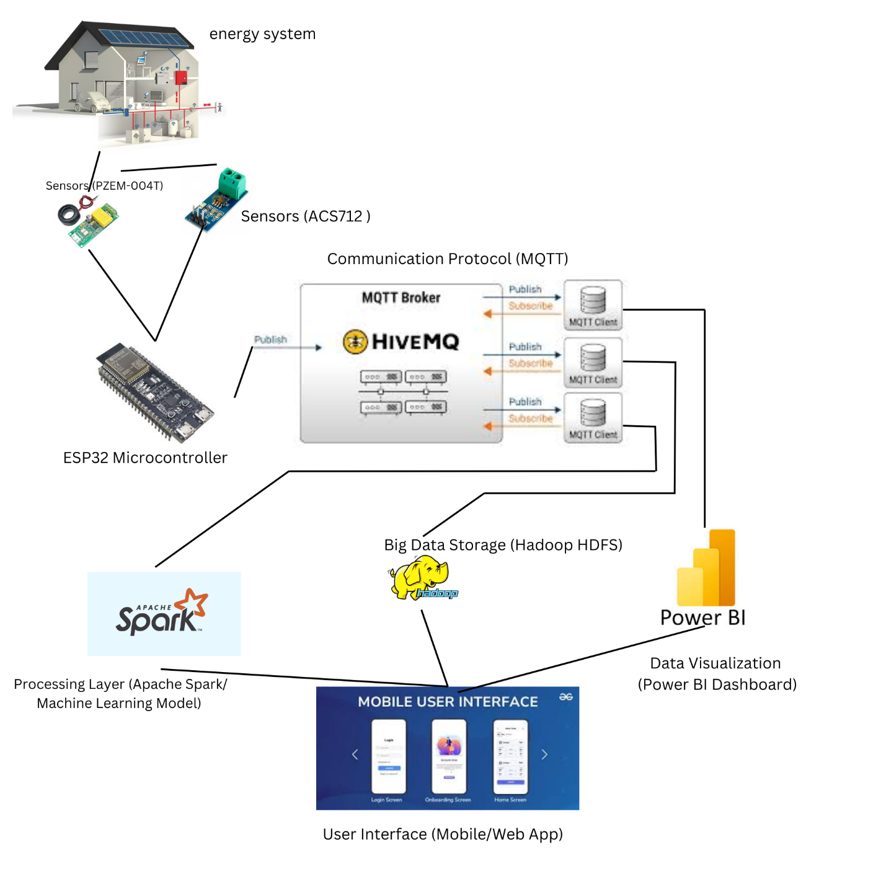

## Overall Architecture Description

Smart Energy Saver System is designed to provide a comprehensive solution for power consumption monitoring and management. The system architecture is divided into four main layers, each servi-ng a specific purpose:  
 **1. Data Collection Layer:**

The sensor collects actual time power consumption data, ESP32 processes and transfers the data to the cloud over WiFi. **2. Data Storage Layer:**

- Collected data is saved in  Hadoop HDFS.  
-Hadoop ensures data reliability and can process data volumes generated by the system. **3. Data Processing Layer:**

**-**Apache Spark is used for real data processing and analysis.  
- Spark analyzes trends, budget tracking, anomaly perception data.  
- Processed data is sent to a machine learning model for visualization and predictive analysis to Power bi . **4. Data Visualization and Analysis Layer:**

**-**Power BI is to create interactive dashboards that visualize energy consumption data.  
- Machine Learning ModelPredictions of future energy consumption and recognition of anomalies.  
- The system sends a notification to the user if energy consumption is approaching household restrictions or if an abnormality is recognized.

## Member Contributions

### Member 1 Contribution: D.M.M.I.T Dissanayaka- IT21174780

D.M.M.I.T Dissanayaka is responsible for the hardware and IoT system development. His key contributions include:

**Configuring the ESP32 microcontroller** to establish a reliable connection with the sensors.

**Integrating the PZEM-004T and ACS712 sensors** for accurate energy consumption measurement.

**Implementing MQTT protocol** to facilitate real-time data transmission from the IoT devices to the cloud/database.

**Setting up the database** to efficiently store and manage collected energy data for further processing.

### Member 2 Contribution: P.A.A Akalanka- IT21160448

P.A.A Akalanka is responsible for **Big Data processing, machine learning, and data visualization**. His key contributions include:

* **Setting up and configuring Hadoop HDFS and Apache Spark** for distributed storage and large-scale data processing.
* **Processing energy consumption data** to derive meaningful insights and detect patterns.
* **Implementing machine learning models** to analyze and predict energy usage trends for optimization.
* **Developing an interactive Power BI dashboard** for real-time visualization and monitoring of energy consumption.

## List of Hardware

**Sensors:**

* **PZEM-004T Power Meter**
* **ACS712 30A Current Sensor**

**Actuators:**

* **Smart Plugs & Relays:** To control appliance power remotely.

**Other Devices:**

* **ESP32 Microcontroller:** For processing and sending data to the cloud.
* **Breadboard and Jumper Wires :** For connecting sensors and actuators.
* **WiFi Module:** For internet connectivity (integrated in ESP32).
* **Power Supply:** To power the ESP32 and sensors.

## Cost Breakdown

|  |  |  |  |
| --- | --- | --- | --- |
| **Component** | **Quantity** | **Unit Price (LKR)** | **Total Price (LKR)** |
| ESP32 | 1 | 3,500 | 3,500 |
| PZEM-004T Power Meter | 1 | 4,500 | 4,500 |
| ACS712 30A Current Sensor | 1 | 800 | 800 |
| Relay Module | 1 | 700 | 700 |
| Breadboard & Wires | 1 Set | 1,200 | 1,200 |
| Power Supply (5V/3.3V) | 1 | 1,500 | 1,500 |
| Total Cost |  |  | **12,200** |

## References

1. **ESP32 Documentation:** <https://www.espressif.com/en/products/socs/esp32>
2. **ACS712 Datasheet:** <https://www.allegromicro.com/en/products/sense/current-sensor-ics/zero-to-fifty-amp-integrated-conductor-sensor-ics/acs712>
3. **Hadoop Documentation:** <https://hadoop.apache.org/>
4. **Power BI Documentation:** <https://learn.microsoft.com/en-us/power-bi/>
5. **Machine Learning with TensorFlow:** <https://www.tensorflow.org/>
6. **Node-RED Documentation:** <https://nodered.org/docs/>